**-ni**

**Practical File**

**Grade XII - TERM II**

**Web Applications (803)**

Submitted By:-

Name: Nakul Uppal

Class: XII C(NM)

Roll No:13665998

**Chak Hakim, Phagwara Punjab**

Submitted To:-

Mr. Amandeep Singh

**Content**

|  |  |  |
| --- | --- | --- |
| **S.No** | **Content** | **PageNo** |
| **1**  **2**  **3**  **4**  **5**  **6**  **7**  **8**  **9**  **10**  **11**  **12**  **13**  **14**  **15**  **16**  **17**  **18**  **19**  **20** | * Introduction of Java Script * Features Of Java * Applications of Java Script * Script tag * How to save and run program in java Script. * Operators in JavaScript * Data Types * Objects * Arrays * Methods * Functions * Events * (i)Printing a line of text in a web page using java script. * (ii)Program to show date and time. * (iii)Program to show the alert box. * (iv)Program to show the confirm box. * (v)Program to show the prompt box. * (vi)Program to call a function. * (vii)Program to show function with an argument. * (viii)Program in which function returns a value. * (ix)Program in which function with arguments returns a value. * (x)Program to find the first occurrence of a text in a string using indexOf() method. * (xii)Program to found off any number using Math.round() method. * (xiii)Program to return a random number between 0 and 1 using random() method. * (xiv)Execution of java script after a page has been loaded. | **4**  **5-7**  **8**  **9**  **9**  **10**  **10**  **11**  **11**  **12**  **13**  **14**  **15-16**  **17-18**  **19-20**  **21-22**  **23-26**  **27-28**  **29-30**  **31-32**  **33-34**  **35-36**  **37-38**  **39-40**  **41-44** |

**Java Script**

**Introduction**

JavaScript is an interpreted computer programming language. It was originally implemented as part of web browsers so that client-side scripts could interact with the user, control the browser, communicate asynchronously, and alter the document contents. Nowadays, JavaScript has become very useful in both game development and the creation of desktop applications.

JavaScript was developed in 1995 by Brendan Eich, at Netscape, and first released with Netscape 2 early in 1996. It was initially called as LiveScript, but was renamed as JavaScript in order to capitalize the popularity of Sun Microsystem's Java language. JavaScript's use in applications outside of web pages also like in PDF documents, site-specific browsers, and desktop widgets and other useful applications. JavaScript was formalized in the ECMAScript language standard and is primarily used as part of a web browser (client-side JavaScript).This enables programmatic access to computational objects within a host environment. JavaScript very quickly gainedwidespread success as a client-side scripting language for web pages. Microsoft introduced JavaScript support in its own web browser, Internet Explorer, in version 3.0, released in August 1996.

**Features of Java Script**

**Browser Support:**

All browsers have accepted JavaScript as a scripting language and provide integrated support for it. For example, to access flash content, you need to install flash plug-in in your browser. But to use JavaScript, you don't have to use any plug-in at all.

**JavaScript can be used on Client Side as well as on Server Side:**

JavaScript has access to Document Object Model DOM of browser. You can change the structure of web pages at runtime. Thus, JavaScript can be used to add different effects to WebPages. On the other hand, JavaScript could be used on the server side as well.

**Functional Programming Language:**

In JavaScript, function could be assigned to variables just like any other data types. A function can accept another function as a parameter and can also return a function. You can have functions with no name as well. This provides you the ability to code in functional programming style.

**Support for Objects:**

JavaScript is an object oriented language. However, the way JavaScript handles objects and inheritance is bit different from conventional object oriented programming languages like C++/ Java. JavaScript supports most of the object oriented concepts while being simple to learn and use.

**Run-time Environment:**

JavaScript typically relies on a run-time environment (e.g. in a web browser) to provide objects and methods by which scripts can interact with "the outside world". In fact, it relies on the environment to provide the ability to include/import scripts (e.g. HTML <script> elements). This is not a language feature as such but it is common in most JavaScript implementations.

**Vendor-specific Extensions:**

JavaScript is officially managed by Mozilla Foundation, and new language features are added periodically. However, only some JavaScript engines support these new features.

**Object based Features Supported by Java Script:**

JavaScript supports various features related to object based language and JavaScript is sometimes referred to as an object-based programming language. Some robust features which JavaScript supports related to object based are as follows:

**Object Type:**

JavaScript supports the development of object types and in this context, JavaScript supports both predefined and user-defined objects. It is possible to assign objects of any type to any variable. It is possible to instantiate the defined object types to create object instances in JavaScript, which is a very powerful feature of Object based language.

**Object Instantiation:**

In order to carry out the process of creating specific object instances available in JavaScript, you can make use of a new operator. These two powerful, object-based features supported by JavaScript described above make this an object model language. In 57 JavaScript, the object types are defined by properties and methods. Properties of Objects are used to access the data values contained in an object. You can make use of the   
properties of JavaScript objects for editing as well as reading depending on the object’s nature. That is, if you want to carry out functions on the object, this is achieved by using methods that make use of the object’s properties. These are some of the features that give JavaScript an ability to handle simple as well as complex tasks. This way, JavaScript has remained as the most popular programming language for a long time. It is also a good language for web designers who want to learn computer programming as it supports object oriented as well as function concepts and to   
use it, you just need a browser and a text editor.

**Applications of Java Script**

**Java Script is used in the following Applications:**

**Developing Multimedia Applications:**

The users can use JavaScript to add multimedia elements. With JavaScript you can show, hide, change, resize images and create images rollovers. You can create scrolling text across the status bar, thus making multimedia applications more interactive.

**Create Pages Dynamically:**

Based on the user’s choice, the date or other external data, JavaScript can produce pages that are customized to the user.

**Interact with the User:**

JavaScript can do some processing of forms and can validate user input when the user submits the form.

**JavaScript Objects are Similar to Dictionaries:**

In JavaScript, objects are just collections of name-value pairs. JavaScript objects are considered as a dictionary with string keys. The users can get and set the properties of an object using either the familiar "." (dot) operator, or the "[ ]" operator, which is typically used when dealing with a dictionary.

**The Script Tag**

*The <SCRIPT> tag alerts a browser that JavaScript code follows. It is typically embedded  
in the HTML.ergt  
<SCRIPT language = "JavaScript">  
statements  
</SCRIPT>*

**Saving and running the program in Java Script**

*Step 1 : Open any editor like notepad and write the program.*

*Step 2 : Save the program in a file with .html extension in a proper folder or subfolder on a drive.*

*Step 3 : Open the web browser like internet explorer or Mozilla Firefox.*

*Step 4 : Open the file you created and save in step 2, to execute the program like to execute C:/JAVA/firstprogram.html*

*Where C is the drive, JAVA is the folder name and firstprogram.html is the name of program which is saved in the Java folder.*

**Operators in Java Script**

*JavaScript operators can be used to perform various operations such as:*

* Arithmetic Operators
* Comparison Operators
* Logical Operators
* Relational Operators
* Assignment Operators
* Conditional Operators

**DataTypes**

A data type is a classification of the type of data that a variable or object can hold. Datatype is an important factor in virtually all computer programming languages, includingvisual basic, C#, C/C++ and JavaScript. When programmers create computer applications,both desktop and web-based, data types must be referenced and used correctly to ensurethe result of the application's functions is correct and error-free.

Some examples of Data Types are:-

(i)String(ii)Int(iii)Boolean

**Objects**

JavaScript objects are simply collections of name-value pairs. The "name" part is a  
JavaScript string, while the value can be any JavaScript value including more objects.  
There are two basic ways to create an empty object:  
var obj = new Object( ); and var obj = { };  
These are semantically equivalent, the second is called object literal syntax, and is moreconvenient.

**Arrays**

Arrays in JavaScript are actually a special type of object. They work similar to regularobjects but they have one magic property called 'length'. The length of the array (size ofthe array) is always one more than the highest index in the array. The traditional way ofcreating arrays is as follows:  
Example:  
var a = new Array();  
a[0] = "dog";  
a[1] = "cat";  
a[2] = "hen";  
a.length

Output: 3

**Methods**

Arrays and string come with a number of methods:  
  
substring() - Extracts the characters from a string, between two specified indices.  
concat() - Joins two or more strings, and returns a copy to the joined strings  
join() - Joins all elements of an array into a string  
pop() - Removes and returns the last item.  
push() - Push adds one or more items to the end.  
reverse() - Reverses the order of an element in an array  
shift() - Removes the first element of an array and returns that element  
slice() - Returns a sub-array.  
sort() - Takes an optional comparison function.  
splice() - Modify an array by deleting a section and replacing it with more items.  
unshift() - Prep ends items to the start of the array.

**Functions**

Functions are the core component for understanding JavaScript. A simple basic functioncan be declared as:  
function add(x, y) {  
var total = x + y;  
return total;  
}  
A JavaScript function can take 0 or more named parameters. The function body cancontain as many statements and can declare its own variables which are local to thatfunction. The return statement can be used to return a value at any time, or terminating thefunction. If no return statement is used (or an empty return with no value) JavaScriptreturns undefined.  
We can call a function without passing the parameters it expects, in which case they willbe set to undefined.

For example: -

function add() {  
var sum = 0;  
for (var i = 0, j = arguments.length; i < j; i++) {  
sum += arguments[i];  
}  
return sum;  
}

Output:  
add(2, 3, 4, 5)  
14

**EVENTS**

The objects in Web pages are organized in a hierarchical structure. All objects haveproperties and methods. In addition, some objects also have "events". Events are thingsthat happen, usually user actions that are associated with an object. The "event handler" isa command that is used to specify actions in response to an event. Below are some of themost commonly used events:  
• onLoad - occurs when a page loads in a browser  
• onUnload - occurs just before the user exits a page  
• onMouseOver - occurs when you point to an object  
• onMouseOut - occurs when you point away from an object  
• onSubmit - occurs when you submit a form  
• onClick - occurs when an object is clicked

**Programming using Java Script**

**Printing a Line of Text in a Web Page Using Java Script**

**<html>**

**<head>**

**<title>Java Print statement</title>**

**</head>**

**<body>**

**<script type=”text/javascript”>**

**document.write(“Pinderi, Karani, Dhaniya, lota & Binga are my dearest friends.”);**

**</script>**

**</body>**

**</html>**

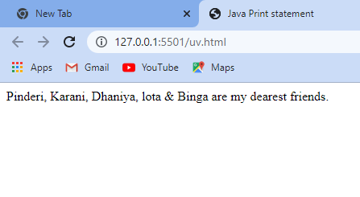

**Program to show date and time.**

**<html>**

**<head>**

**<title>javaname</title>**

**</head>**

**<body>**

**<script type="text/javascript">**

**var d=Date();**

**document.write(d);**

**</script>**

**</body>**

**</html>**

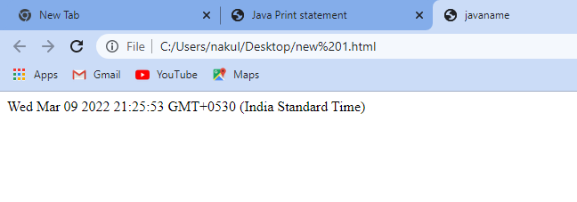

**Program to show the Alert Box**

**<html>**

**<head>**

**<title>alert box</title>**

**<script type="text/javascript">**

**var a=10;**

**var b=20;**

**if(a>b)**

**{**

**alert("A is greater.");**

**}**

**else**

**{**

**alert("B is greater.");**

**}**

**</script>**

**</head>**

**<body>**

**</body>**

**</html>**

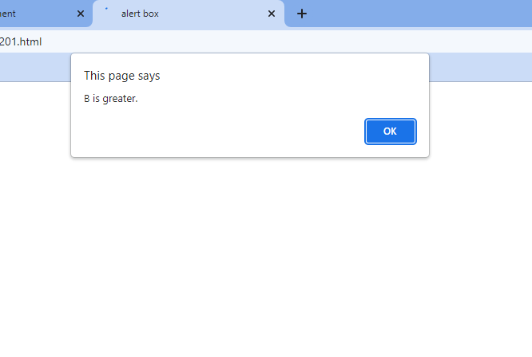

**Program to show the Confirm Box**

**<html>**

**<head>**

**<title>Confirm Box</title>**

**<script type="text/javascript">**

**var a=confirm("Do you like our website?");**

**if(a)**

**{**

**alert("Thank you");**

**}**

**else**

**{**

**alert("Sorry for the inconvenience BRO...");**

**}**

**</script>**

**</head>**

**<body>**

**</body>**

**</html>**

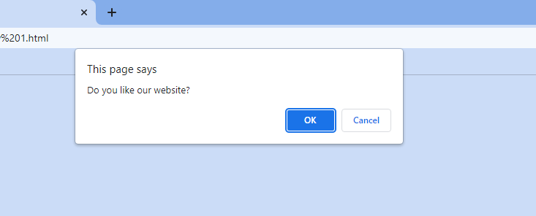

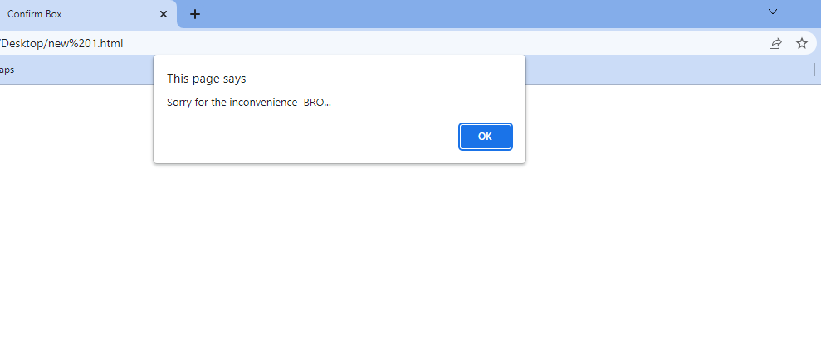

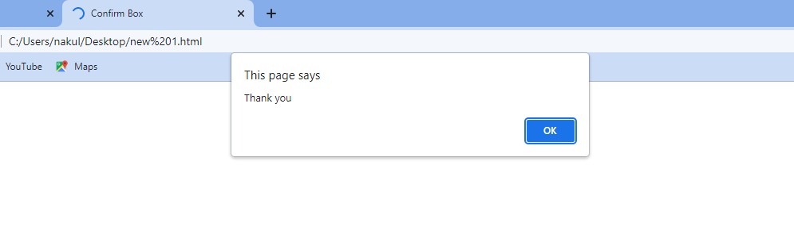

**Program show the prompt box**

**<html>**

**<head>**

**<title>Prompt Box</title>**

**<script type="text/javascript">**

**var per=prompt("Enter your percentage....");**

**if (per>=80 && per<=100)**

**{**

**document.write("You are in Merit.");**

**}**

**else if(per>=60 && per<80)**

**{**

**document.write("You are in First division.");**

**}**

**else if(per>=45 && per<60)**

**{**

**document.write("You are in Second division.");**

**}**

**else if(per>=33 && per<45)**

**{**

**document.write("You are in Third division.");**

**}**

**else if(per<33)**

**{**

**document.write("You are Fail.");**

**}**

**else**

**{**

**document.write("Please enter valid percentage.");**

**}**

**</script>**

**</head>**

**</html>**

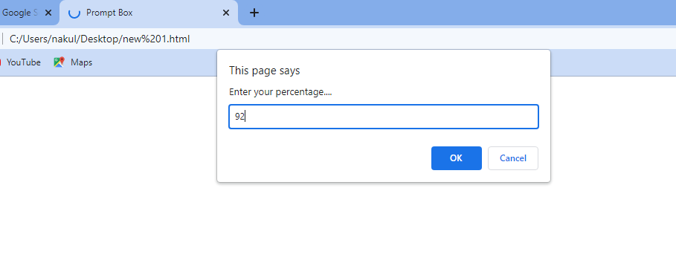

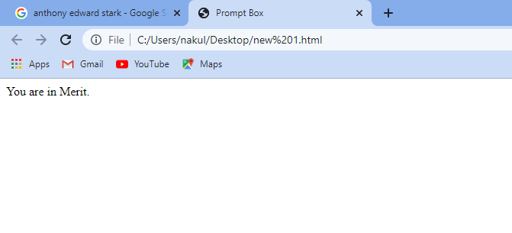

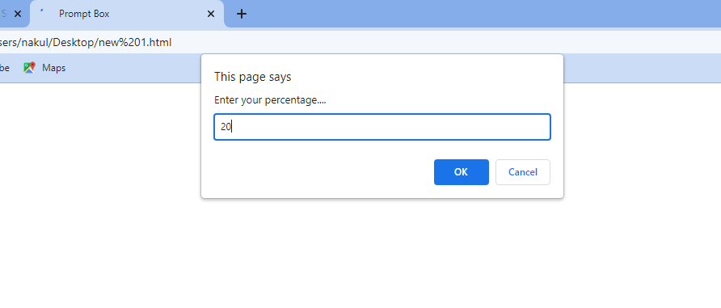

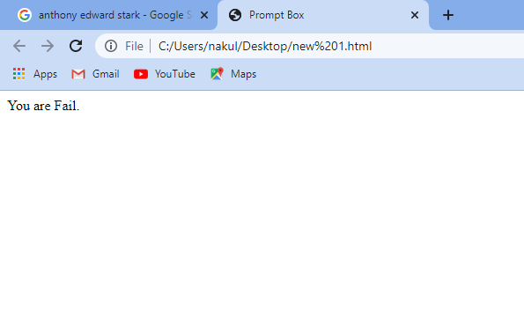

**Program to call a Function**

**<html>**

**<head>**

**<title>calling function</title>**

**<script type="text/javascript">**

**function display()**

**{**

**document.write("Light has multiple personality disorder because it has dual nature");**

**}**

**display();**

**</script>**

**<body>**

**</body>**

**</head>**

**</html>**

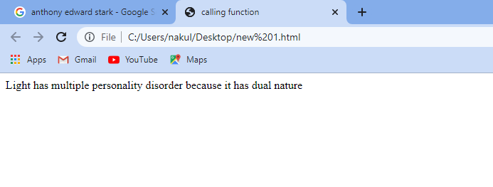

**Program to show function with an argument.**

**<html>**

**<head>**

**<title>Arguments</title>**

**</head>**

**<body>**

**<script type="text/javascript">**

**function disp(name1,name2)**

**{**

**arguments[1]="Hello";**

**document.write(arguments[0]+"");**

**document.write(arguments[1]+"");**

**}**

**disp("Ashneer Grover hates light due to its dual nature")**

**</script>**

**</body>**

**</html>**

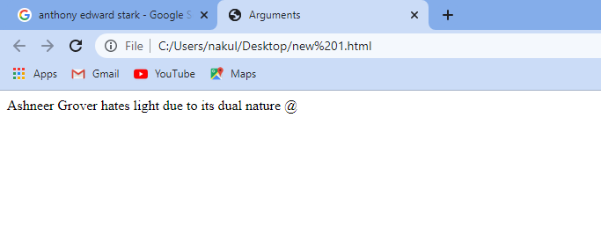

**Program containing value returning function**

**<html>**

**<head>**

**<title>returning function</title>**

**</head>**

**<body>**

**<script type="text/javascript">**

**function sum(math,eng,sci)**

**{**

**var s=math+eng+sci;**

**return (s);**

**}**

**function percentage(tt)**

**{**

**var per=(tt/300)*100;**

**document.write(per);**

**}**

**var total=sum(100,90,87);**

**percentage(total);**

**</script>**

**</body>**

**</html>**

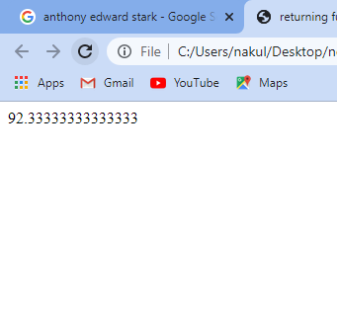

**Program with function with arguments that returns a value**

**<html>**

**<head>**

**<title>returning arguments values</title>**

**</head>**

**<body>**

**<script type="text/javascript">**

**function add(a,b)**

**{**

**return (a+b);**

**}**

**var x=add(69,96);**

**document.write(x);**

**</script>**

**</body>**

**</html>**

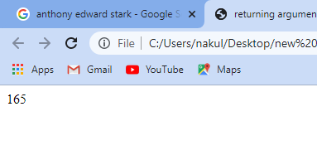

**Program to find the position of the first occurrence of a text in a string using indexOf()**

**<html>**

**<head>**

**<title>indexOf method</title>**

**</head>**

**<body>**

**<script type="text/javascript">**

**var str="Indian Education System is a big TRASH.";**

**var result=str.indexOf('T');**

**document.write("The index of occurance I is "+result);**

**</script>**

**</body>**

**</html>**

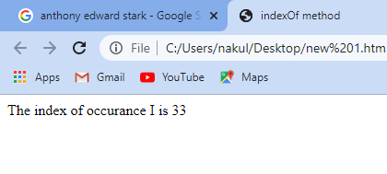

**Program to round off any number using round()**

**<html>**

**<head>**

**<title>round off method</title>**

**</head>**

**<body>**

**<p id="disp"></p>**

**<script type="text/javascript">**

**document.getElementById("disp").innerHTML=Math.round(6.9);**

**</script>**

**</body>**

**</html>**

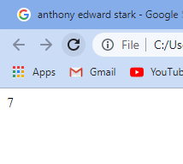

**Program to return a value random number between 0 and 1 using random()**

**<html>**

**<head>**

**<title>random</title>**

**</head>**

**<body>**

**<script type="text/javascript">**

**document.write(Math.random());**

**</script>**

**</body>**

**</html>**

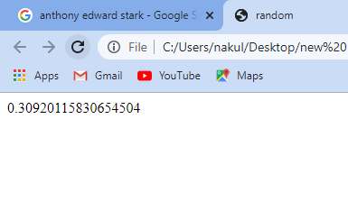

**Execution of javascript immediately after a page has been loaded.**

**<html>**

**<head>**

**<title>Prompt Box</title>**

**<script type="text/javascript">**

**var per=prompt("Enter your percentage....");**

**if (per>=80 && per<=100)**

**{**

**document.write("You are in Merit.");**

**}**

**else if(per>=60 && per<80)**

**{**

**document.write("You are in First division.");**

**}else if(per>=45 && per<60)**

**{**

**document.write("You are in Second division.");**

**}**

**else if(per>=33 && per<45)**

**{**

**document.write("You are in Third division.");**

**}**

**else if(per<33)**

**{**

**document.write("You are Fail.");**

**}**

**else**

**{**

**document.write("Please enter valid percentage.");**

**}**

**</script>**

**</head>**

**</html>**

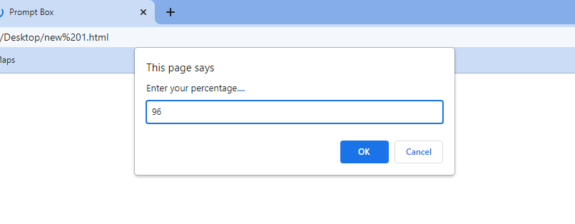

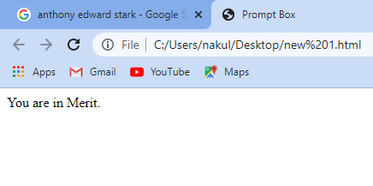

**Execute a javascript when a button is clicked.**

**<html>**

**<head>**

**<title>alert box</title>**

**<script type="text/javascript">**

**var a=87;**

**var b=97;**

**if(a>b)**

**{**

**alert("A is greater.");**

**}**

**else**

**{**

**alert("B is greater.");**

**}**

**</script>**

**</head>**

**<body>**

**</body>**

**</html>**

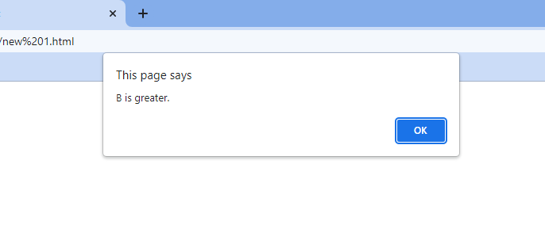

Thank You